14 January 2024
Dear Friend of Millbank or guest
A special Quiz on Military Medical History.
This Quiz is open to anyone interested in military medical history or heritage, regardless of membership of Friends of Millbank.
You are not expected to know all the answers, but I hope you will know some of them. Some questions are much easier than others. I’ll give you one hint – search through our website, you may find some answers there, or clues where to look further.
You don’t have to answer every question before sending me your response. Just have a go. I hope you will enjoy the challenge. You may even win a prize.
Please feel free to share this Quiz with friends, colleagues, students and would-be historians – it could even be a unit effort or a team-building exercise. Challenge others to do better than yourself.
Please send me your answers, and I’ll let you know how you’ve done.
I look forward to hearing from you.
You are also most welcome to attend our monthly talks, which are open to all. Do consider joining Friends of Millbank if you have not already done so. Subscribing members (£20 p.a.) can attend talks for free and also have affiliate BSHM membership and access to over 30 recordings of previous high quality talks in our Members Area, a unique educational resource.
I wish you all a peaceful and healthy year ahead.
In Arduis Fidelis
David Vassallo
chairman@friendsofmillbank.org
Friends of Millbank 2024 Quiz – Military Medical History.
A: Hospitals. B: Paintings and Artists. C: Quotations. D: Famous personalities.
Replies to chairman@friendsofmillbank.org
Your name and email:
A. Famous Military hospitals.
Name the hospital and its location, and dates it opened and closed.
Can you name any famous person, or any battle / campaign / military Operation, or published history, or website associated with it?

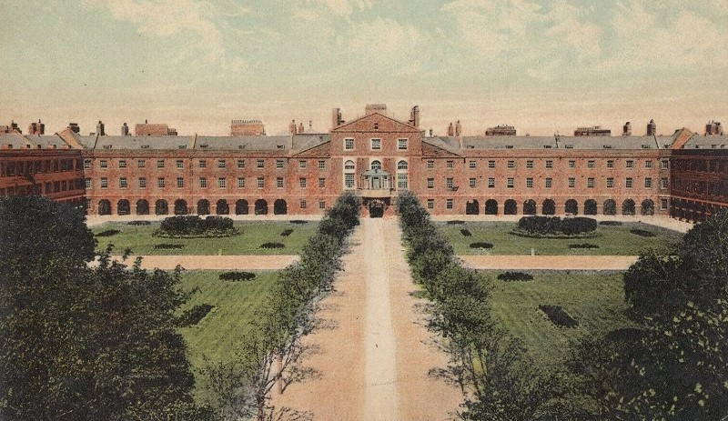
Figure One
(name? location? dates? Famous person? Published history? website?):

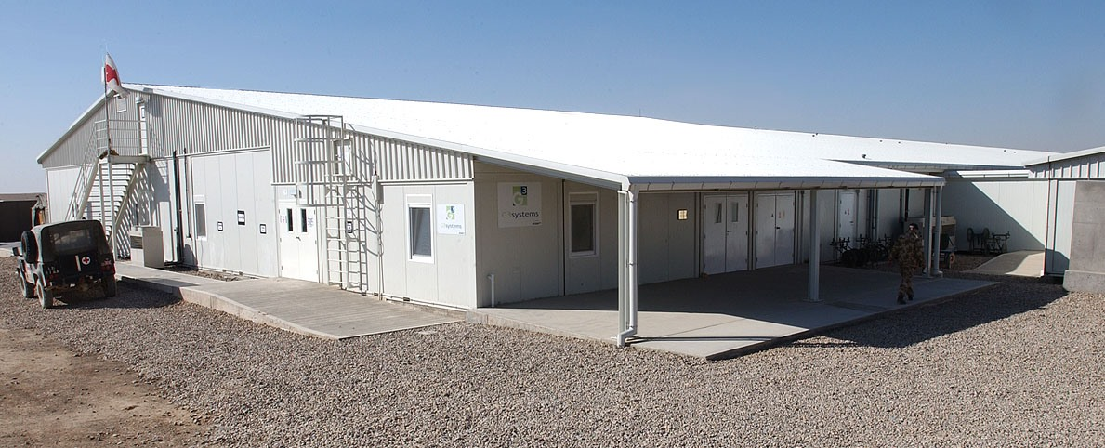
Figure Two
(name? location? dates? Campaign or military Operation? Published history?):

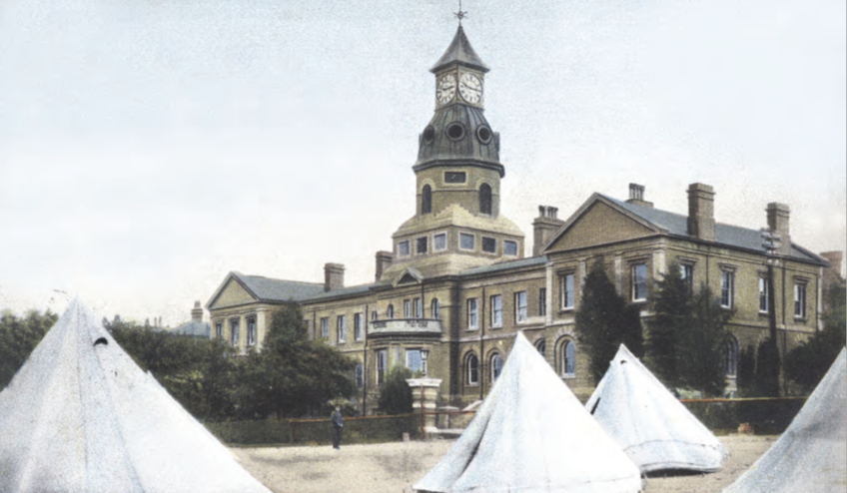
Figure Three
(name? who is it named after? location? dates? Famous WW1 surgeon? Published history?):

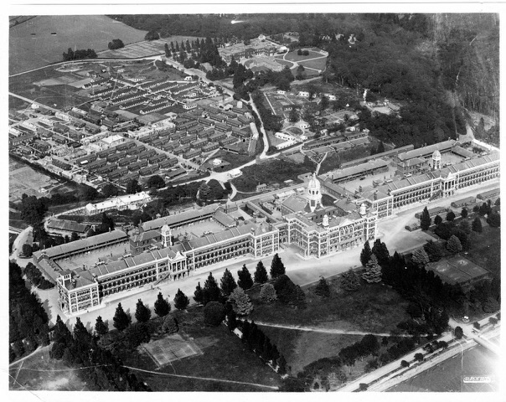
Figure Four
(name? location? dates? Who used it in 1944? Published history? Associated website?):

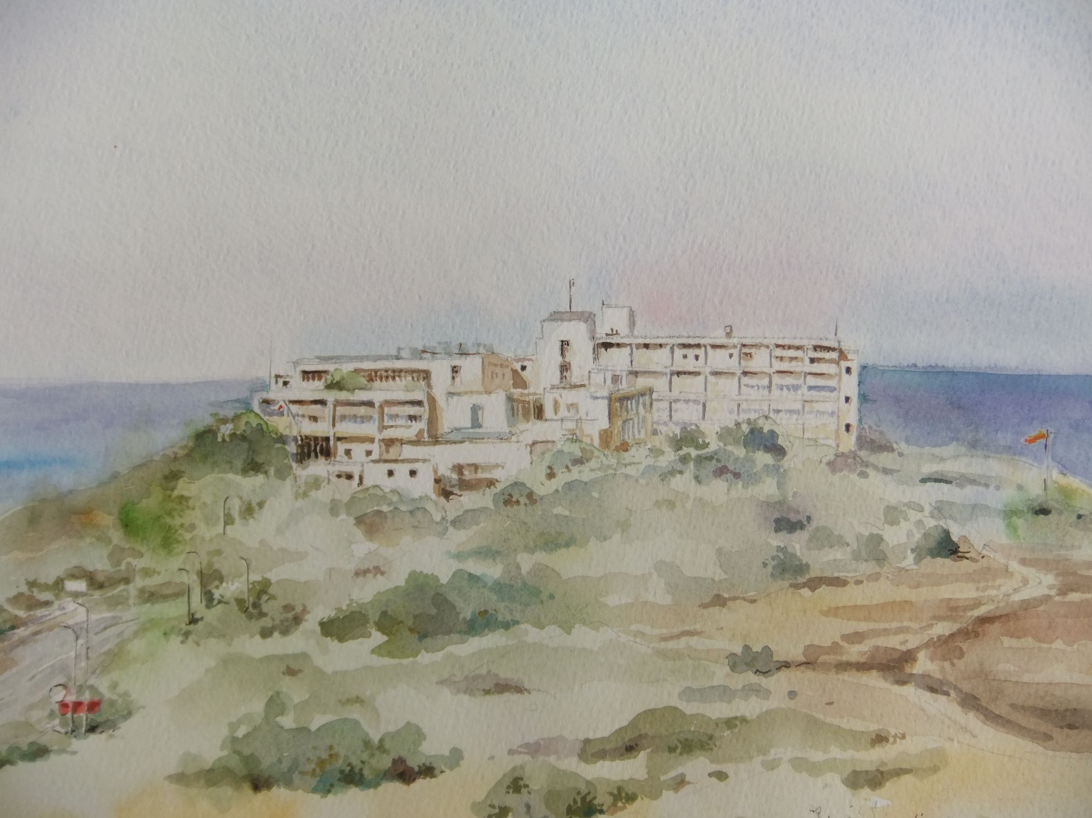
Figure Five
(name? location? dates? artist? Famous hostage treated here? History?):

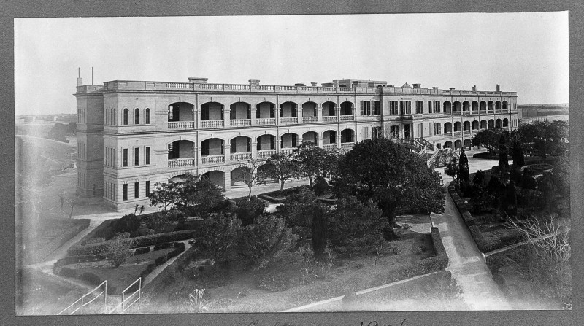
Figure Six
(name? location? dates? Who influenced design? Current use?):

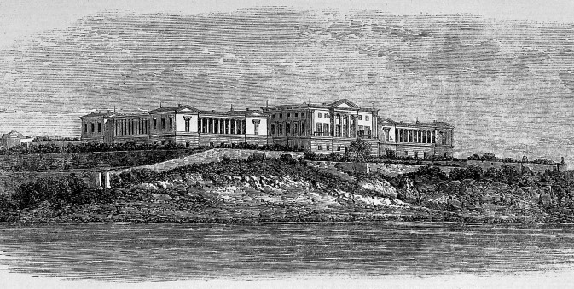
Figure Seven
(name? location? dates? Associated with which personality?):

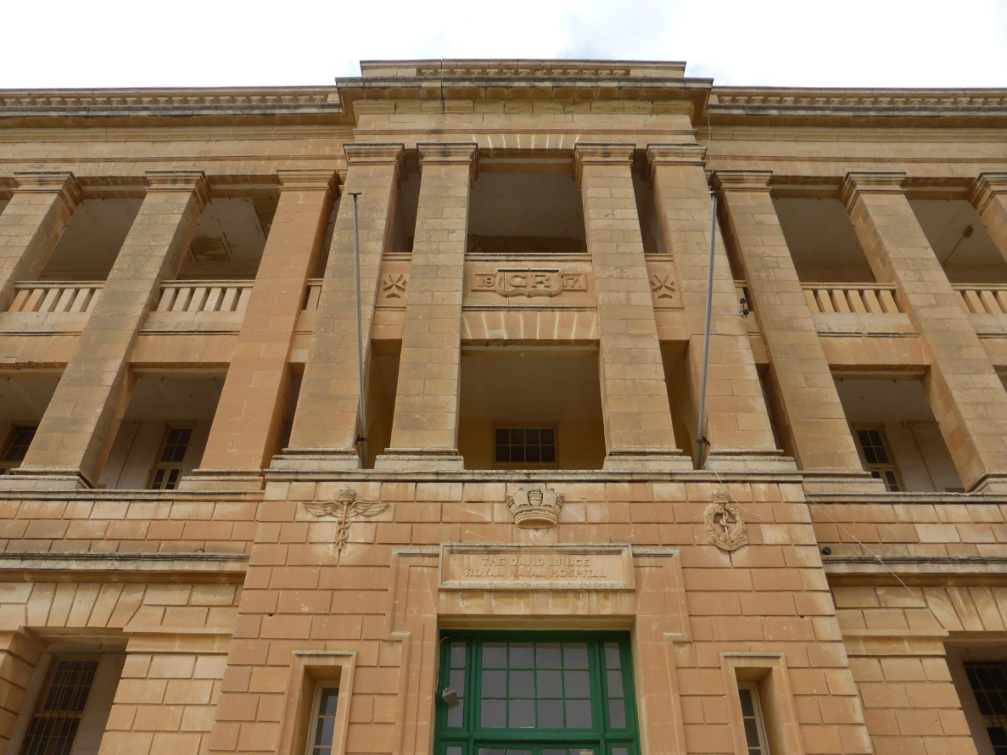
Figure Eight
(original name? location? dates? WW2 designation? Post-WW2 name? Final name?):

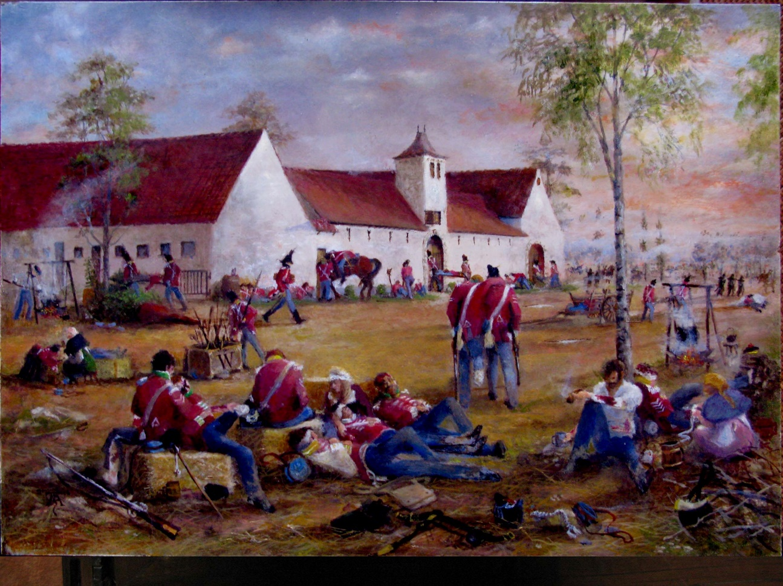
Figure Nine
(name? location? Associated with which battle? Associated website?):

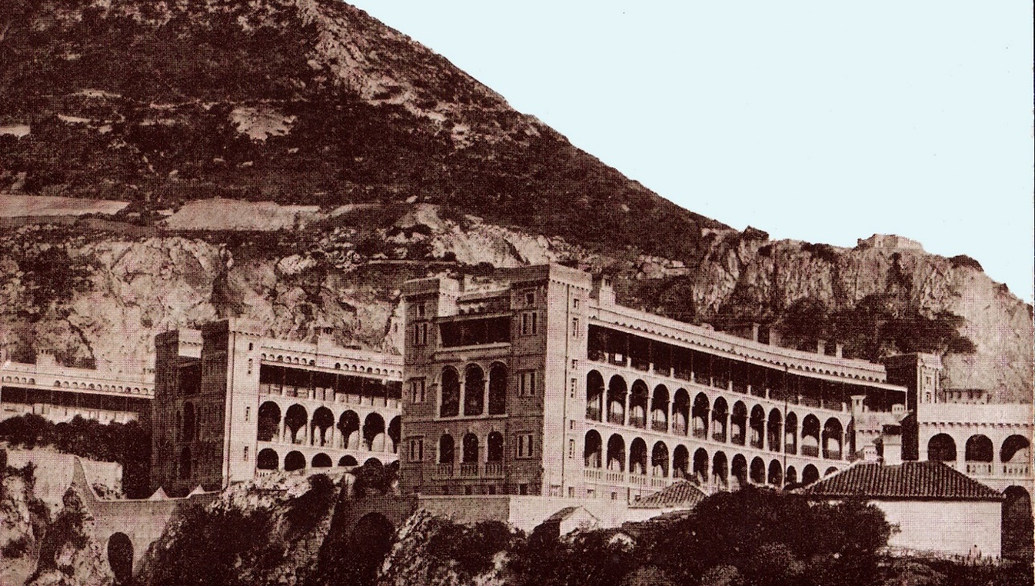
Figure Ten
(original name? location? Post-WW2 name? dates?):

A. Military hospitals.

ANSWERS:
Figure One.
Figure Two.
Figure Three.
Figure Four.
Figure Five.
Figure Six.
Figure Seven.
Figure Eight.
Figure Nine.
Figure Ten.

A. Military hospitals – Published histories / Associated websites.

ANSWERS:
Figure One.

Figure Two.

Figure Three.

Figure Four.

Figure Five.

Figure Six.

Figure Seven.

Figure Eight.

Figure Nine.

Figure Ten.

B. Military Medical Paintings & their Artists.

Match the painting to the artist. Also name the painting or give extra detail about it.
Choose from:

1. Rachael Andrews (RAMC, medical support officer)
2. Stuart Brown (artist)
3. David Cobb (artist)
4. Arabella Dorman (artist)
5. Tony Green (RAMC, sergeant)
6. Graeme Lothian (artist)
7. Julia Midgley (artist)
8. Gora Pathak (RAF, orthopaedic surgeon)
9. Gilbert Rogers (artist)
10. David Rowlands (artist)
11. Gordon Rushmer (artist)

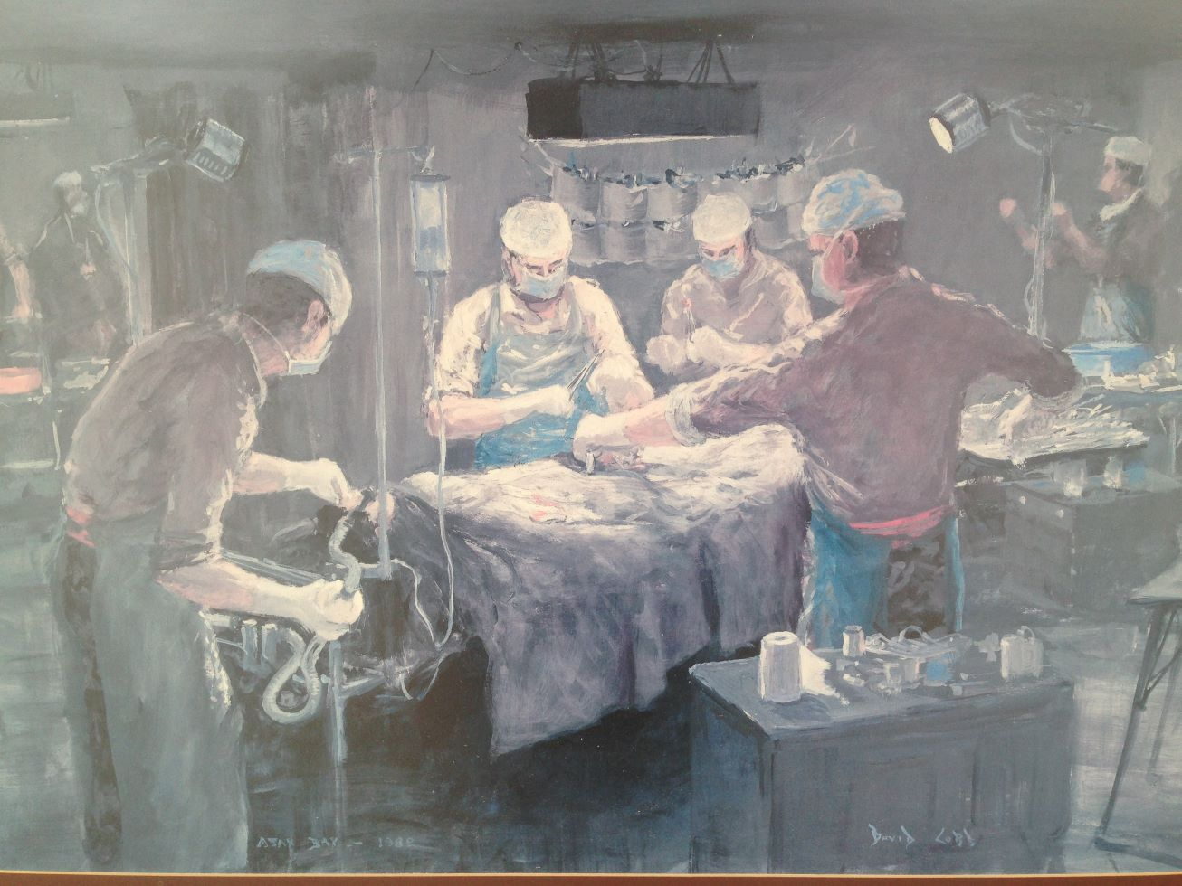
Figure One
(Name of painting? War? Name of military operation? Artist? Published history?)
Also name the designer of the operating table, and author of:
‘A Simple Operating Frame For Field Use’ (J Roy Army Med Corps 1967; 1: 134-137)

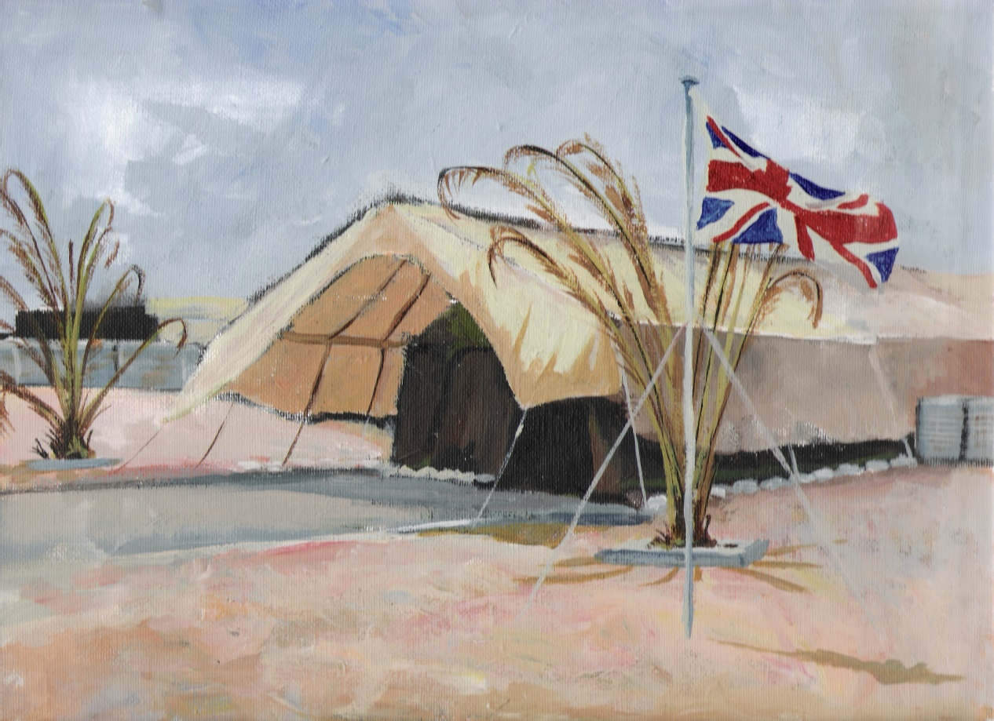
Figure Two
(Location? War? Operation? Artist?):

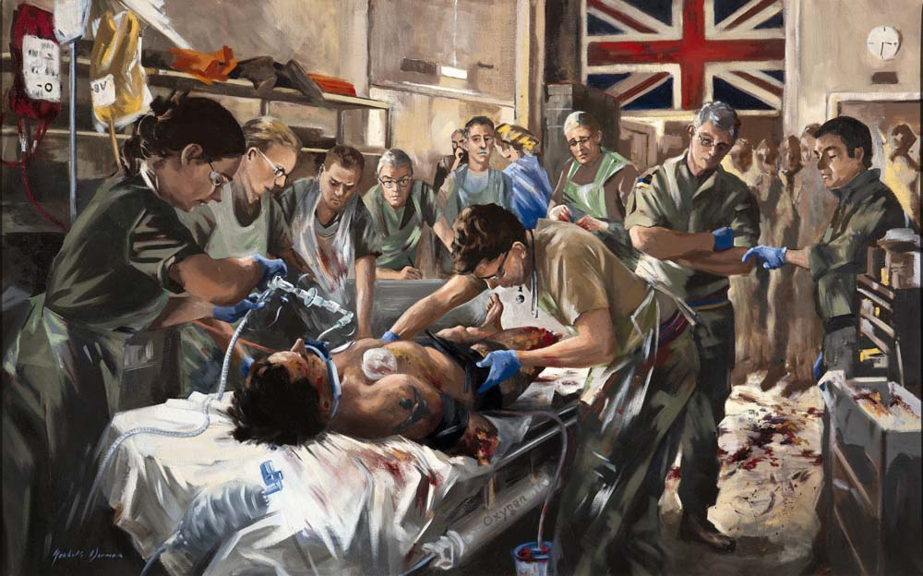
Figure Three
(Location? Operation? Artist?):

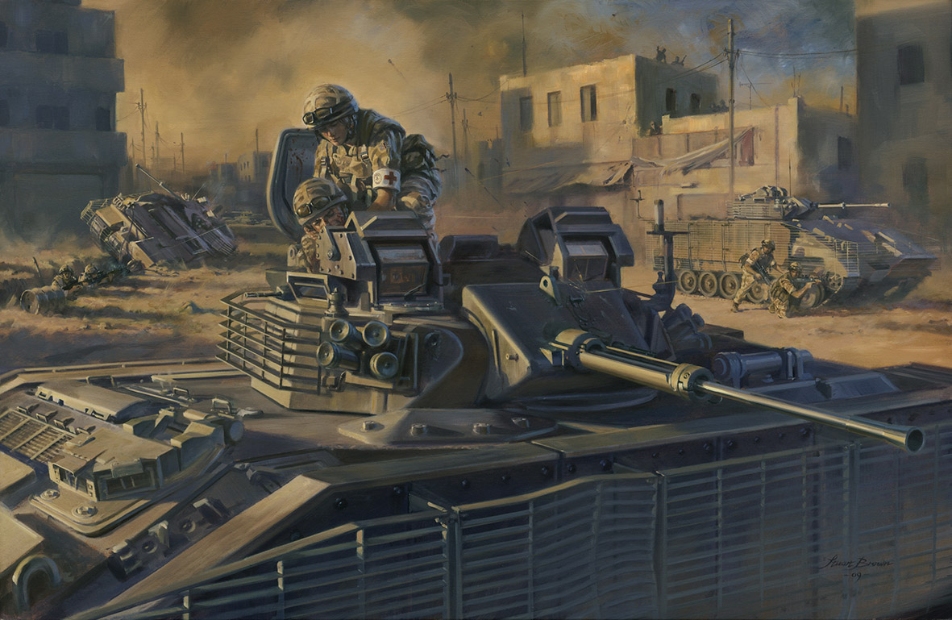
Figure Four
(Name the person with the armband. Significance? War? Operation? Artist?):

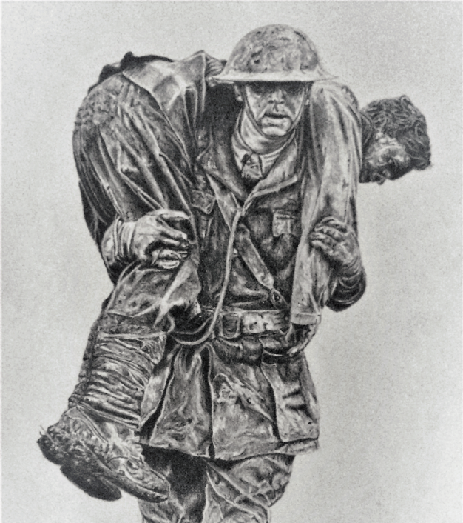
Figure Five
(War? Name the helmet and date of introduction. Artist?):

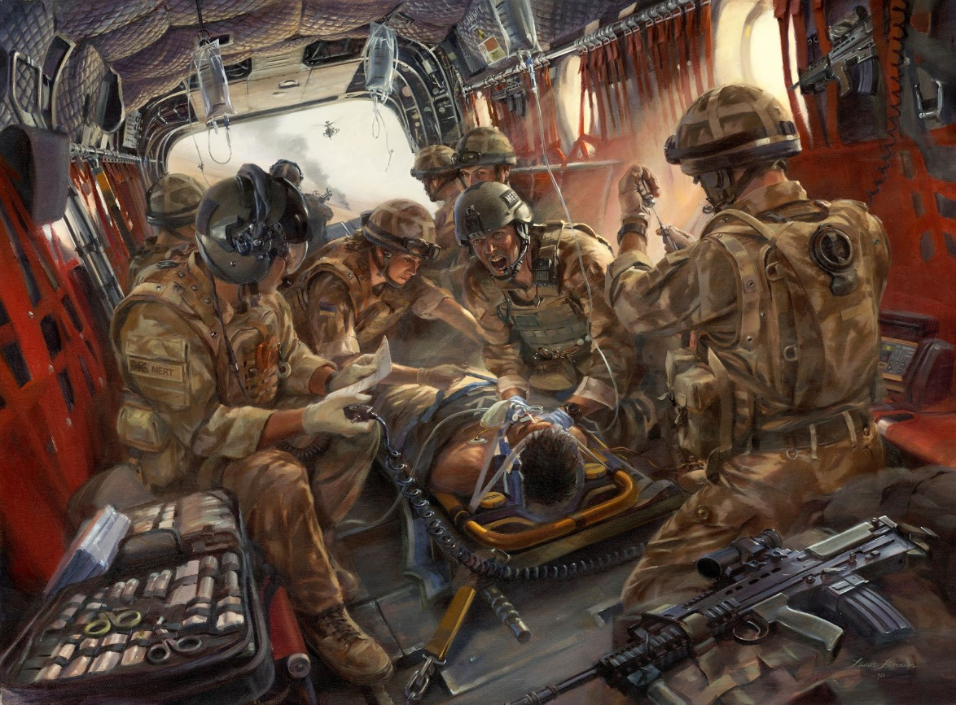
Figure Six
(Name of Painting? What team is shown in the painting? Operation? Artist?):

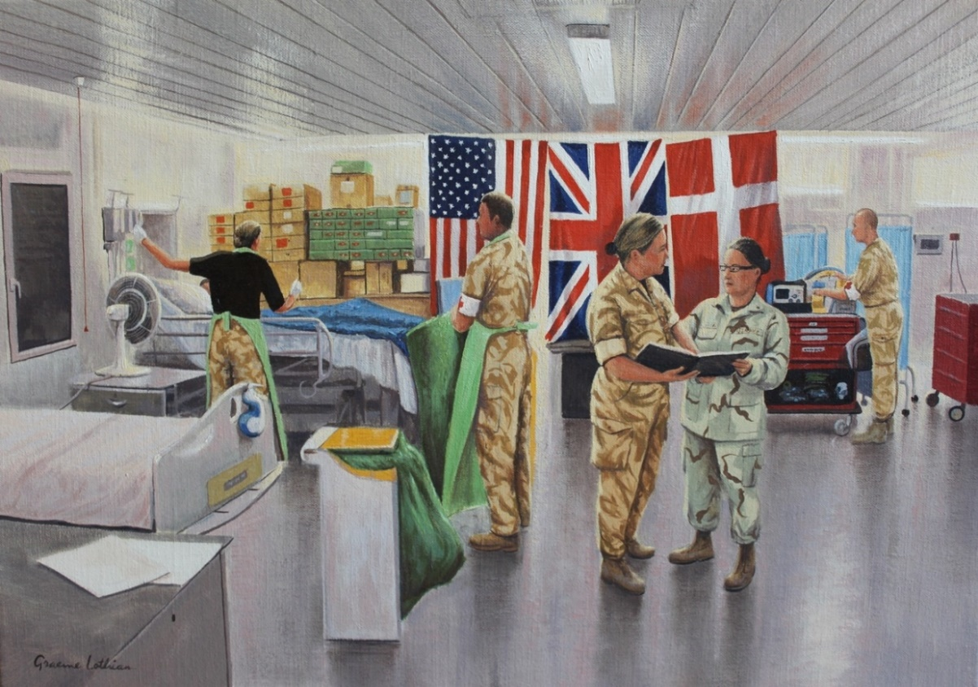
Figure Seven
(Location? Operation? Artist? History? Website?):

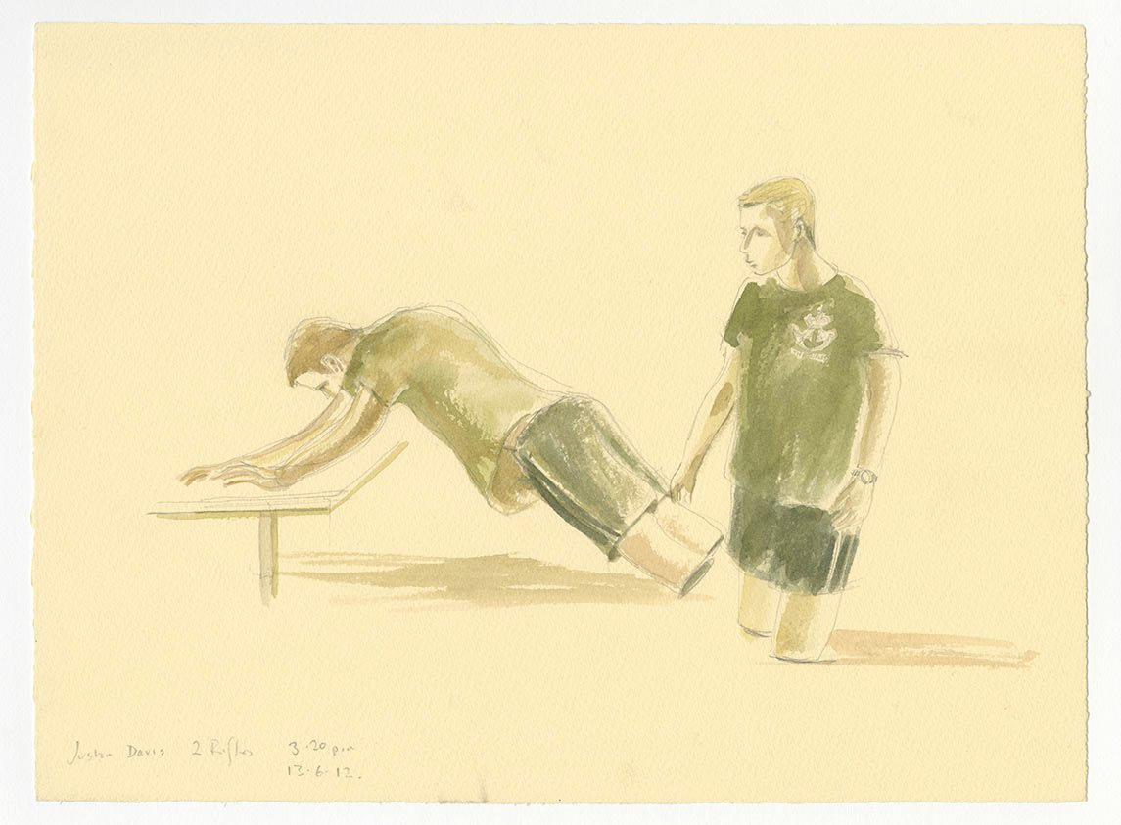
Figure Eight
(Name of painting? Artist?):

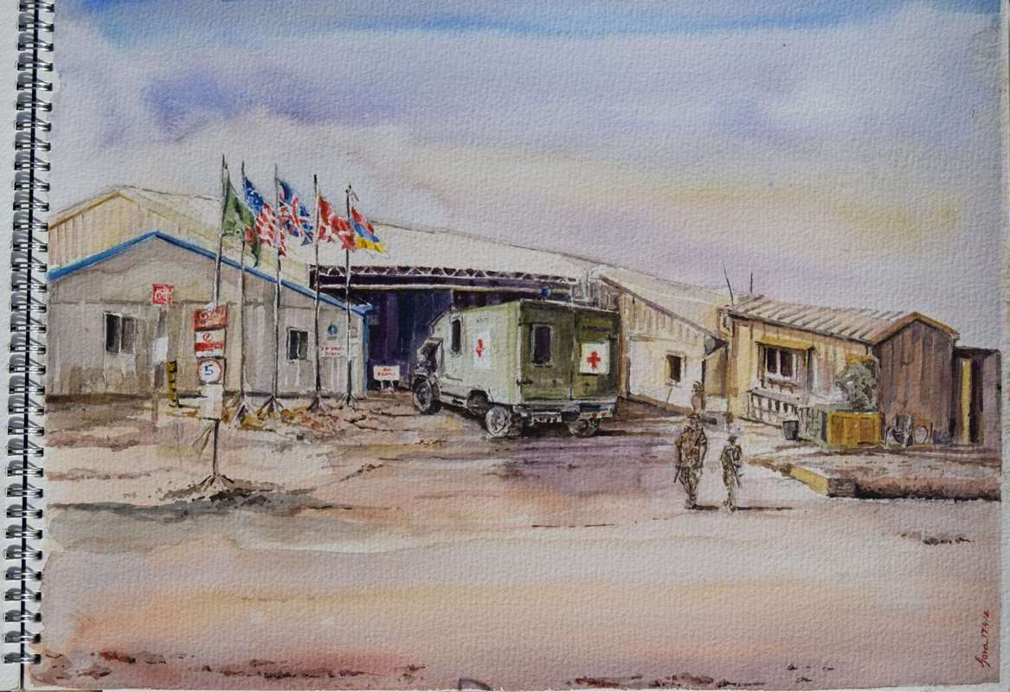
Figure Nine
(Location? Operation? Artist?):

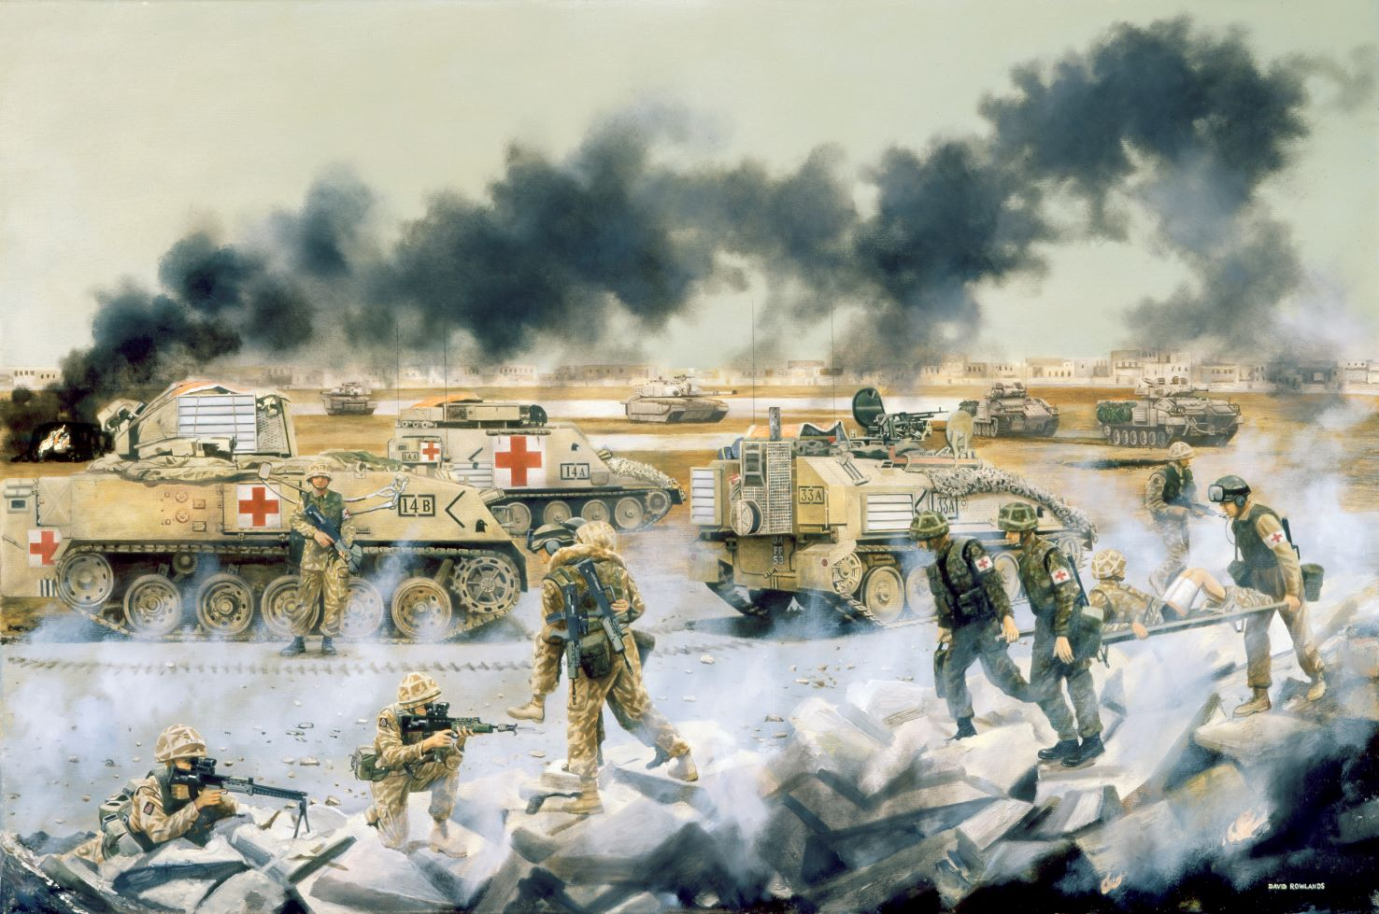
Figure Ten
(Name of painting? War? Operation? Artist?):

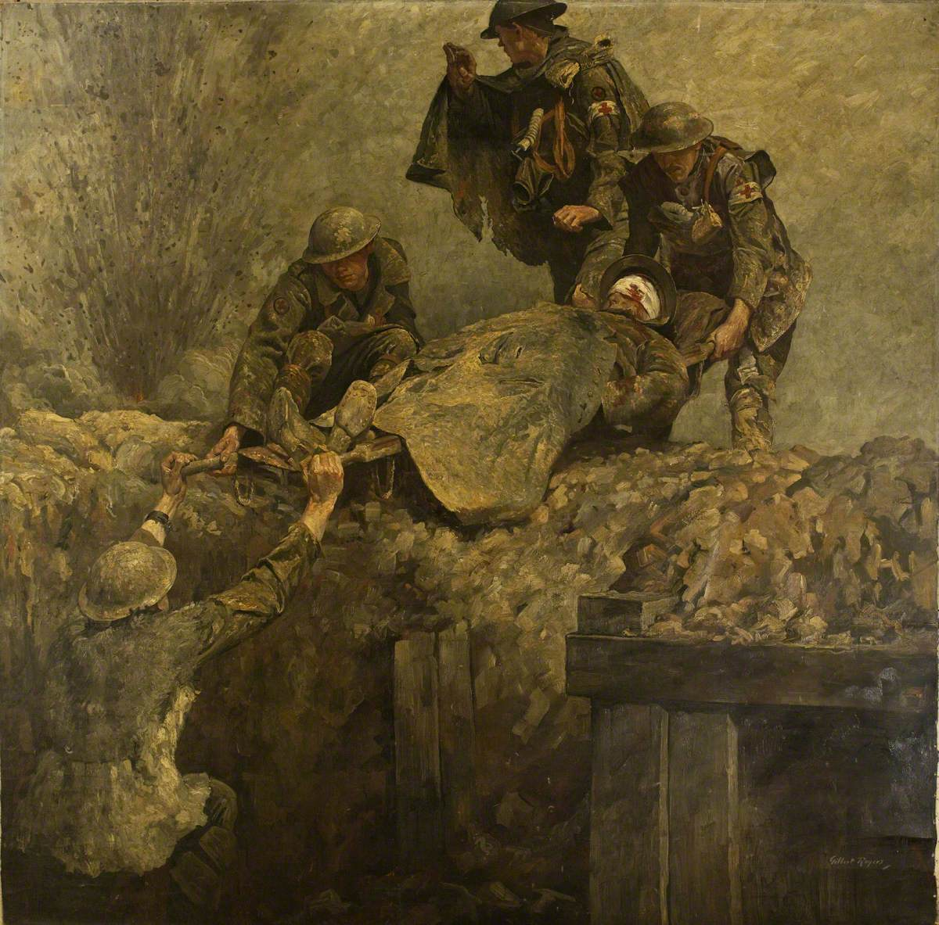
Figure Eleven
(Name of painting? War? Location of original painting? Artist?):

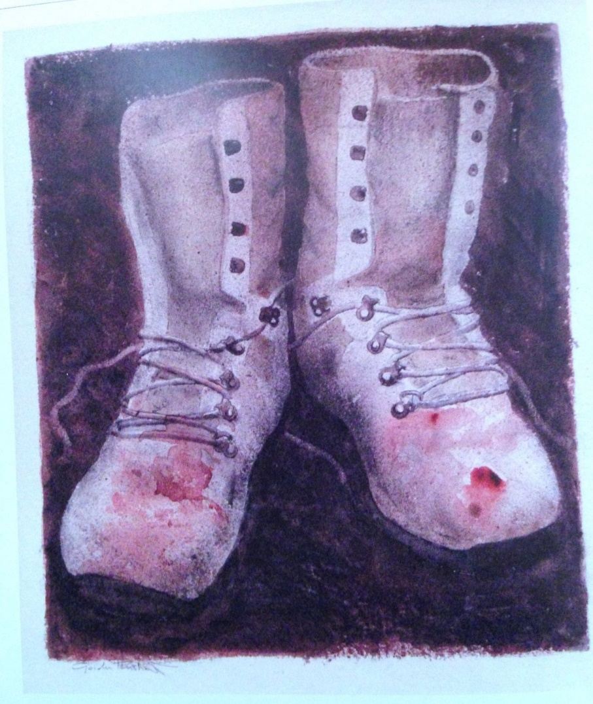
Figure Twelve
(Name of painting? Artist?):

B. Military Medical Paintings & their Artists.
ANSWERS:
Figure One:
Figure Two:
Figure Three:
Figure Four:
Figure Five:
Figure Six:
Figure Seven:
Figure Eight:
Figure Nine:
Figure Ten:
Figure Eleven:
Figure Twelve:

C. Famous military medical quotations.
Name the author, and the source.

Q1a. Who said ‘A wounded enemy is no longer an enemy but a comrade in need of help’?

Q1b. At which major conference were these words uttered? (Date, name and purpose?)

Q2. Who said ‘There can be little doubt that it is in the investigation of disease with a view to its prevention that our foremost duty lies.’?

Q3. Who said ‘If anything positive can be said of war, it would be that it serves as a catalyst for rapid improvements in medical understanding and care’?

Q4. Who said ‘The medical officer is no longer regarded merely as the physician or surgeon to treat disease or wound; he is the guardian of the health of armies and fleets.’?

Q5. Who said ‘Give her my love, tell her Duty called and called me to obey.’

Q6. Who said ‘Je le pensay, et Dieu le guarit.’ Please translate the words.

Q7. Who said ‘‘We wish to bring to the humblest soldier the best available surgery, and that which is not the best is not good enough’?

D. Famous military medical personalities.
Match the image to the person, and name their main wartime role.

Choose from:  1. Sir David Bruce (1855-1931)  2. Captain Noel Chavasse VC & Bar, MC (1884-1917)  3. Sir Edward ‘Weary’ Dunlop (1907-1993)  4. Harold Gillies (1882-1960) |  | 5. George James Guthrie (1785 – 1856)  6. Sir Alfred Keogh (1857-1936)  7. Bernhard von Langenbeck (1810-1887)  8. Dominique Jean Larrey (1766-1842)  9. Sir James McGrigor (1771-1858)
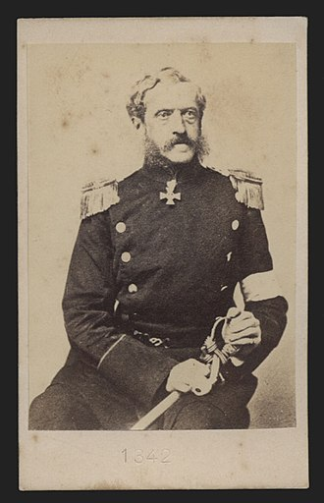  Figure One | 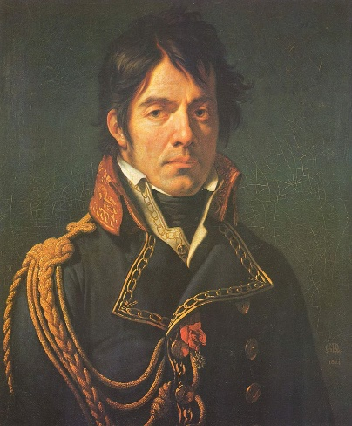Figure Two |  | 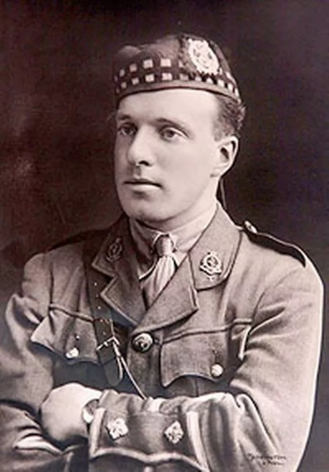  Figure Three
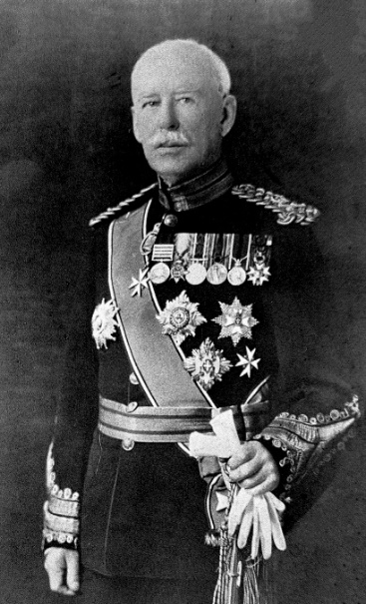  Figure Four | 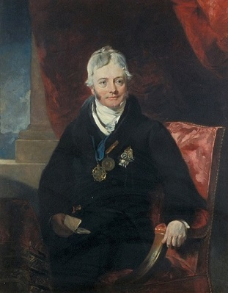  Figure Five |  | 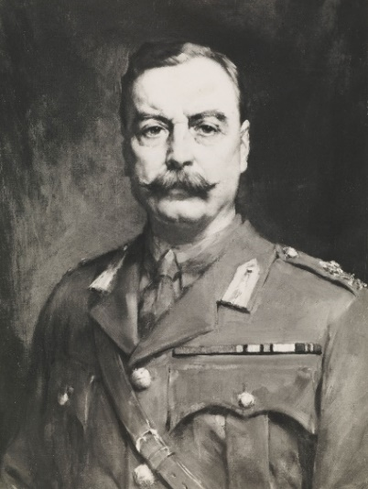  Figure Six
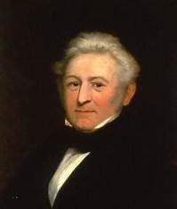  Figure Seven | 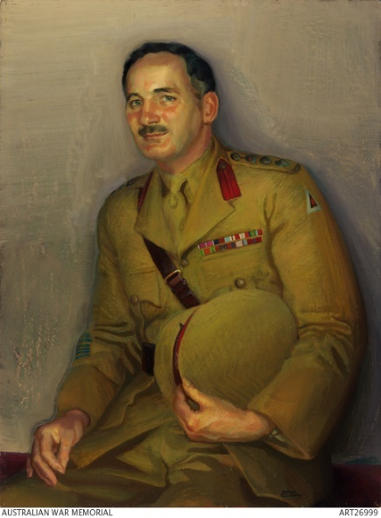  Figure Eight |  | 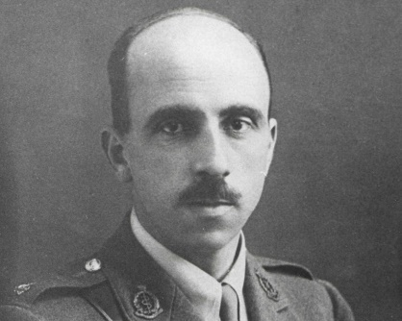  Figure Nine
D. Famous military medical personalities.

ANSWERS:

Figure One:
Figure Two:
Figure Three:
Figure Four:
Figure Five:
Figure Six:
Figure Seven:
Figure Eight:
Figure Nine:

